US Grade 6 – Pre-test
10 Questions | 30-45 minutes | Calculator allowed
1. A grocery store has 23 red apples and 38 green apples. What is the ratio of green apples to total apples?
- 23 : 38
- 38 : 23
- 61 : 38
- 38 : 61

2. Which expression is equivalent to $8x+28$ ?
- $8(x+20)$
- $7(x+4)+x$
- $8(x+4)+4$
- $7(x+3)+x$

3. Which shape is formed by the net above?
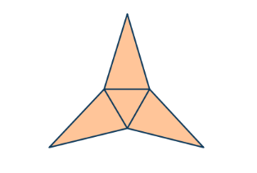
- Triangular pyramid
- Triangular prism
- Square pyramid
- Isosceles triangle

4. Chantal makes 8 bracelets with 3 yards of string. How many yards of strings does she need for 12 bracelets?
- 32
- 2$\frac{2}{3}$
- $4\frac{1}{2}$
- $5\frac{1}{3}$

5. Below are the total scores for the first 5 games Otto’s baseball team played.
Total scores: 5, 9, 2, 2, 8.
What is the mean of the total scores?
- 5.2
- 7
- 2
- 5.1

6. A pair of shoes was one sale for 25% off. After the discount, Kyla paid $36 for the pair of shoes. What was the original price?

- $12
- $45
- $9
- $48

7. Solve $500.76 ÷ 5.2$

- 98.1
- 96.3
- 96.156
- 95.4

8. Alma is painting the outside of the box above - an isosceles triangular prism.
How many square inches does she paint?
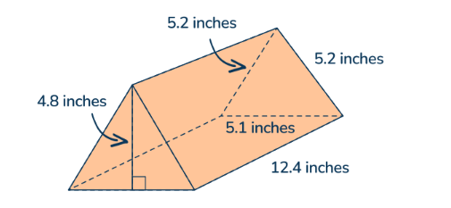

- 1,578.4704
- 303.552
- 216.68
- 37.2

9. Estelle is five years older than her brother Dorian. Which equation(s) show the relationship between Estelle’s age, d. Select all the correct answers.
- $d-5=e$
- $d+5=e$
- $e-5=d$
- $e-d=5$

10. Point B is in Quadrant 4 and 3.5 units away from Point A.
Point C is Point B reflected across the y-axis.
What are the coordinates of Point C?
- (2.5,1.5)
- (-1.5,-2)
- (-1,-2)
- (1,2)

